STATEMENT OF PURPOSE

Name of establishment or agency | Vale View Dental Care
Address and postcode | Vale View House  Canola, Sarn  Bridgend,  CF32 9TY
Telephone number | 01656 721145
Email address | reception@valeviewdentalcare.co.uk
Fax number | N/A
Website | www.valeviewdentalcare.com

Aims and objectives of the establishment or agency

At Vale View Dental Care we aim to provide general dental services to the public, that are safe, caring, efficient, and responsive to patient’s needs, by a well led and managed team.

We aim to:

- Provide high quality dental care, including periodic examinations and treatment where required

- Promote good oral health to all patients attending for care and advice

- Understand and meet the needs of our patients, involve individuals in decisions about their care and encourage them to participate fully

- Involve other professionals in the care of our patients i.e. referral for specialist care and advice, when this is in the patient’s best interest

- Promote the benefits of general and oral health to the wider population by participating in local initiatives

- Ensure that our team have the right skills and training to carry out their duties competently and with confidence

- Ensure the team are aware of current national guidelines and ensure it is reflected in care for our patients.

We provide a full range of general dental services to all patients, NHS, Private and Practice Plan patients:

- The diagnosis and treatment of dental disease including caries and periodontal disease
- Treatment of oral trauma
- Providing dental restorations
- Providing dentures and bridges
- Dental extractions
- Radiographs (taking and diagnosing)
- Soft tissue screening
- Emergency dental treatment
- Orthodontic assessment and referral for comprehensive treatment
- Provide cosmetically focused adult orthodontics with Cfast
- Fixed and removable orthodontic treatment for adults and children

REGISTERED MANAGER DETAILS

Name | Christian Peter Francis Hoes
Address and postcode | Vale View Dental Care  Vale View House  Canola, Sarn  Bridgend  CF32 9TY
Telephone number | 01656 721145
Email address | reception@valeviewdentalcare.co.uk
Fax number | N/A
Relevant qualifications

BDS Wales 2011
Vocational Foundation Training 2012
GDC No. 210332
IQT Bronze Level 2017
Membership with Agilio Quality Practice Scheme

Relevant experience

I graduated from Cardiff Dental School in 2011 and completed my vocational dental training in 2012. I spent just over a year in general practice as an Associate Dentist before taking over Vale View Dental Care in December 2013.

Since then, I have run the day-to-day business of the dental practice and all that it entails from staff and financial management to always ensuring patient safety and excellent quality of care.

In addition to my role as a clinical dentist, I also:

- Oversee the daily operational procedures/protocols in the practice.

- Responsible for recruitment, training, development of my employees along with day-to-day supervision.

- Ensuring the building and equipment are in good working order and schedule of servicing is kept up to date.

- Have an overall responsibility for implementation and monitoring of health and safety policies and procedures ensuring all risks are identified and reduced.

- Have an overall responsibility of complaints, accidents or untoward events, documenting, investigating, and resolving any issues.

- Have an overall responsibility for financial decisions in the practice

- Using patient feedback to improve the service we provide.

- Ensuring all regulatory duties are completed

I have developed the practice from a single surgery (dentist only) practice to a two-surgery practice, with a hygienist / dental therapist service and separate central decontamination facilities. I have introduced digital radiography to further improve patient safety and practice payment plans to help make costs more manageable for patients.

I have utilised the Agilio iComply dental compliance software to implement practice policies and procedures and keep up to date with all the numerous rules, legislation and regulations which govern the running of a dental surgery, especially in relation to health and safety. I have a contract with Agilio to support me in my role as a responsible employer and for HR management.

I regularly attend training courses to increase my knowledge on radiation protection, patient safety, quality assurance, infection control and other aspects of practice management. As I am the only dentist, I also attend courses to improve my clinical skills and keep up to date with the rapidly changing techniques and materials, whilst maintaining the ethos - prevention is better than cure.

Both the practice manager and I have completed bronze level quality improvement training and are making use of the Maturity Matrix Dentistry self-evaluation tool to help us self-evaluate and improve the quality and safety of patient care at the practice. We recently achieved certification for meeting Agilio standards of patient safety, care and service.

I am aware of my duty with regards to expected patient service and have established and continually monitor the practices complaints and feedback mechanisms.

STAFF DETAILS

Name | Position | Relevant qualifications / experience
Christian Hoes | Principle Dentist | BDS Wales 2011, Vocational Dental Training 2012 IQT Bronze Level 2017 GDC no. 210332. Practice owner since December 2013. Cfast Labial certificate. Certificate of training with The Academy By Ash – Smile Design, Restorative and Occlusion Course. Orthodontic Assure Core of Knowledge certificate. Provides general dental services and Orthodontic treatment at the practice. First Aid at work."
Mariah Cassam | Practice Manager | NVQ Level 3 Dental Nursing – Learn Kit Making Prevention Work in Practice. BDA Education Certificate in Dental Radiography March 2023. IQT Bronze Level 2020. GDC no. 280319. First Aid at work.
Eve Wilson | Dental Therapist | BSc Dental Therapy and Hygiene,  University of Plymouth, 2024. GDC No: 317847
Lois Cocks | Clinical Manager/Head Dental Nurse | Level 3 Diploma in Dental Nursing C&G. Decontamination Lead. IQT Bronze Level 2022. Fire Marshal. GCSE’s A-C in English, Mathematics, Science, Numeracy, RE, Health & Social, Geography, Art and Welsh Baccalaureate. AS Level in Criminology and Art. Experience working in retail and hospitality which has given me customer service skills and confidence to interact with customers and peers.
Mia Johns | Trainee Dental Nurse | GCSE’s A-C in English, Mathematics, History, Geography, Religious Studies, Biology, Chemistry, Physics, Food technology and Physical Education.  A Levels: Physical Education (first year) B, Business Studies:B, Applied Science: High Merit and Welsh Baccalaureate:B  One Year Undergraduate: Biomedical Sciences, Biochemistry: D, Infection & Immunity: C, Microbial Work: A, Cell Biology and Genetics: C.
Lexy Coles | Trainee Dental Nurse | Currently working towards Level 3 Diploma in Dental Nursing since October 2023. GCSE’s A*-C in Welsh, English, Science, Mathematics, RE, Health and social, Photography, Welsh Baccalaureate. AS level in Medical Science and Health and Social care. Experience working in hospitality which helped me build good communication skills as well as team working skills. As well as this, it also helped me understand the importance of responsibilities in the workplace.
Molly Honeywell | Trainee Dental Nurse | Currently working towards Level 3 Diploma in Dental Nursing since January 2023. Completed 12 month program to achieve retailer and customer service level two apprenticeship. Completed 10 week program on team leader management training. GCSE’s A*-C in English, Mathematics, Biology, Geography, Physical Education, Art and Design, Graphic Design and Drama. Experience working as a team leader / supervisor in previous job roles.

ORGANISATIONAL STRUCTURE

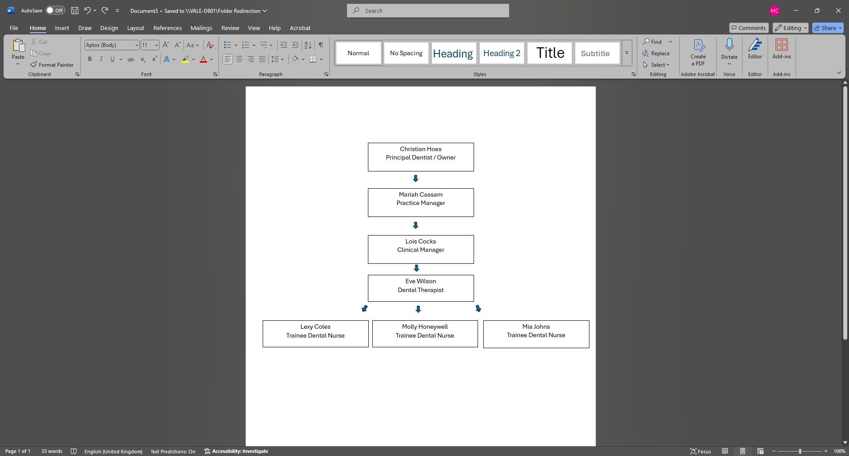

SERVICES / TREATMENTS / FACILITIES

We provide general dental services to patients of every age. We offer a full range of NHS and Private general dental treatment as detailed below, including the diagnosis and treatment of dental disease including caries and periodontal disease.

We also take radiographs as an aid to diagnosing the patient’s oral condition and undertake dental extractions where necessary.

We are available to treat oral trauma and can follow it up by providing dental restorations.

Related to this, we provide emergency dental treatment for our patients and new patients to the practice.

In relation to the area of wider health, we also undertake soft tissue screening for the early detections of oral cancers.

A full list of treatments are recorded below:

Dental examinations
Digital Radiographs-intra and extra oral
Photographs – intra and extra oral
Periodontal treatment
Oral Hygiene Instruction
Behaviour management
Administration of local anaesthetic
Amalgam restorations
Composite restorations
Glass Ionomer restorations
Primary root canal treatment – Using the Wave one X - Smart Plus endodontic motor
Secondary root canal treatment within the dentist’s clinical competence
Tooth extractions
Surgical tooth extractions within dentist’s clinical competence
Provision of extra coronal restorations: crowns/post crowns/inlays/on lays/bridgework/porcelain veneers within the dentist’s clinical competence
Provision of dentures: Acrylic/cobalt chrome/Valplast dentures within dentist clinical competence
Denture relines and additions
Treatment of dentine sensitivity
Provision of night shields for TMD/tooth wear cases
Provision of sports gumshields
Internal and external tooth whitening
Cosmetic tooth alignment using Cfast
Referrals to specialists for treatment out of the dentist’s clinical competence
Fixed and removable orthodontic treatment for adults and children

We have 2 surgeries, 2 waiting rooms, 2 toilets, a separate decontamination room and staff room. The downstairs surgery, waiting room and toilet are suitable for patients in wheelchairs.

PATIENTS VIEWS

We regularly ask patients for their views on our service.
We have comments and suggestions forms available at the practice, patient surveys, and new patient surveys, these are completed regularly. We also have suggestions box displayed at reception as well as on our website for patients to leave their feedback. We have recently implemented ‘Working Feedback’ which prompts patients online to leave feedback after their visit.
We reflect on the findings and find out what patients like about the practice, what they feel could be improved and what it is really like to receive dental care at the practice.
Our questionnaires are designed to be as short and as simple as possible and jargon free, making it easier for patients to respond and simplify our analysis.

We take patients views and suggestions seriously and implement any changes we feel can benefit the practice, our patient care and experience, this demonstrates our commitment to keeping them informed and involved in the practice.

ARRANGEMENTS FOR VISITING / OPENING HOURS

Practice opening hours are as follows: -

Monday 9.00am to 5.30pm (Lunchbreak 1 - 2 pm)
Tuesday 9.00am to 5.30pm (Lunchbreak 1 - 2 pm)
Wednesday 9.00am to 6.00pm (Lunchbreak 1 - 2 pm)
Thursday 9.00am to 5.30pm (Lunchbreak 1 - 2 pm)
Fridays 8.30am to 2.00pm

We are a caring practice and aim to offer same day appointments to patients in pain or with an urgent dental problem.

Should an emergency occur out of practice hours, the answer phone message has details of how you can obtain emergency care and advice.

All patients can call the NHS emergency dental helpline on 0300 123 5060 for out of hours treatment and advice.

Practice plan and Private patients can call 07908 729166 for advice.

ARRANGEMENTS FOR DEALING WITH COMPLAINTS

Our complaints procedure is displayed in our waiting room and available in print.

Complaints should be addressed to Mariah Cassam, our Complaints Manager/Practice Manager. Alternatively, an appointment can be made to discuss the patient’s concerns.

We will acknowledge the complaint within 2 working days and we aim to have investigated the complaint within 30 working days.

A private complaints leaflet is given to private, or practice plan patients and an NHS complaints leaflet is given to NHS patients together with a copy of the NHS Wales ‘Putting Things Right’ leaflet.

We will investigate the circumstances by seeking the view of the relevant team members, examine the patient’s record and if necessary, contact our defence organisation.

In investigating the complaint, we aim to:

- Find out what the complaint was about
- Enable the person complaining to discuss the issue
- Ensure an apology is given, where appropriate
- Enable us to reflect on what we can do to make sure this issue doesn’t arise again

In the event of the practice being unable to resolve the issue the patient would be given the following information contained in our patient concerns leaflets:

NHS patients are directed to:

- Welsh Language Commissioner by calling 0845 6033 221 or visiting http://www.comisiynyddygymraeg.cymru.
- Local Community Health Council by calling 01443 405830.
- The Ombudsman for Wales by calling 0300 790 0203 or visiting www.ombudsman-wales.org.uk.
- Healthcare Inspectorate Wales (HIW) who is the independent inspectorate and regulator of all healthcare in Wales by calling 0300 062 8163.
You can also write to them at:
Healthcare Inspectorate Wales
Welsh Government
Rhydycar Business Park
Merthyr Tydfil
CF48 1UZ
- The General Dental Council online form at www.gdc-uk.org contact them on information@gdc-org.uk or by calling 020 7167 6000.

Private patients are directed to:
- GDC private dental complaints service within 12 months of the treatment or within 12 months of becoming aware of the issue by calling 020 8253 0800 or visiting www.dentalcomplaints.org.uk.

PRIVACY AND DIGNITY

Our practice is committed to providing services to all patients within the constraints of our building. We also ensure that people can make choices regardless of their race, age, gender, sexual orientation, disability and religion or beliefs.

There is disabled access to the rear of the building, and we have improved
physical access by ensuring the path to the practice is well lit and has a smooth surface that is free from obstacles. We have a designated disabled parking bay. We have a handrail to help assist patients and a doorbell at the rear situated at a lower level for wheelchair users.

The ground floor also consists of a disabled toilet with an emergency pull-cord.

The ground floor waiting room has an uncluttered open passage to the surgery providing easy access for those with walking difficulties or in wheelchairs. We have a hearing loop available at reception.

Information for patients is primarily printed in English and is available in Welsh on request, along with large print information. Cwm Taf Morgannwg LHB can organise translators for other languages via Language Line. A trained B.S.L interpreter is available on request. We monitor closely the patient profile of the practice and will produce information in different languages, if required.

Each surgery is equipped with a comprehensive range of illustrated patient information and life-sized and large-scale models to help describe various treatment options. The surgeries have large monitors on which radiographs and intra oral photos can be shown to patients when discussing treatment options.

We ensure care of patients is always appropriate to their specific needs, i.e., avoiding complex treatment plans for terminally ill patients or referring patients to specialist facilities if necessary. We encourage patients with learning difficulties or language difficulties to bring a family member or carer with them to ensure the patient understands treatment options.

We aim for positive oral health promotion for all patients. The team tries to develop a good relationship with all patients to they can help them maintain good oral health.

Date Statement of Purpose written | 09.12.17
Author | Christian Hoes

STATEMENT OF PURPOSE REVIEWS

Date Statement of Purpose reviewed | 09/07/2018
Reviewed by | Kelly Williams and Christian Hoes
Date HIW notified of changes | 09/07/2018

Date Statement of Purpose reviewed | 09/07/2019
Reviewed by | Kelly Williams and Christian Hoes
Date HIW notified of changes | Not applicable

Date Statement of Purpose reviewed | 13/07/2020
Reviewed by | Kelly Williams and Christian Hoes
Date HIW notified of changes | Not applicable

Date Statement of Purpose reviewed | 15/07/2021
Reviewed by | Kelly Williams and Christian Hoes
Date HIW notified of changes | Not applicable

Date Statement of Purpose reviewed | 22/09/2022
Reviewed by | Kelly Williams and Christian Hoes
Date HIW notified of changes | Not applicable

Date Statement of Purpose reviewed | 21/12/2023
Reviewed by | Mariah Cassam and Christian Hoes
Date HIW notified of changes | 02/01/2023

Date Statement of Purpose reviewed | 02/04/2024
Reviewed by | Mariah Cassam and Christian Hoes
Date HIW notified of changes | 02/04/2024

Date Statement of Purpose reviewed | 03/06/2025
Reviewed by | Mariah Cassam and Christian Hoes

